

**Riphah International University Lahore**



**Project Title: Active POS**

**Submitted to: Mr. Talha Tariq**

**Group Members:**

**Shakeel Ahmad (48237)**

**Abdul Samad (48865)**

**DEPARTMENT OF COMPUTER SCIENCE RIPHAH INTERNATIONAL UNIVERSITY LAHORE.**

**Introduction**

Active POS is an advanced online platform that simplifies purchasing and inventory management for retailers and wholesalers. It offers features like user authentication, product management, and invoice generation for smooth transactions. Active POS tackles common sales and inventory challenges with solutions for cart management, vendor integration, and detailed reporting. This helps businesses manage stock and sales efficiently, boosting their effectiveness and profitability.

**Objective**

Create an online POS system that boosts sales, manages inventory, and handles invoicing to improve business operations and customer satisfaction.

**Final Outcome**

A user-friendly online POS platform that connects businesses with customers, enhances inventory tracking, and simplifies sales processes while offering detailed financial records.

**Goals**

* Improve sales operations with efficient product and inventory management.
* Enhance customer experience with a smooth and reliable purchasing process.
* Optimize resources by accurately tracking stock and sales data.
* Offer detailed reporting tools for better financial and inventory decisions.

**Functions**

* User authentication and profile management.
* Product listing and inventory management.
* Sales processing and cart management.
* Invoice generation and payment processing.
* Vendor management and product supply tracking.
* Detailed reporting and analytics for sales and inventory.

**Methodology**

* Develop a user-friendly interface for both administrators and customers.
* Implement robust product and inventory management functionality.
* Integrate secure payment gateways and invoicing features.

**ERD OF POS:**

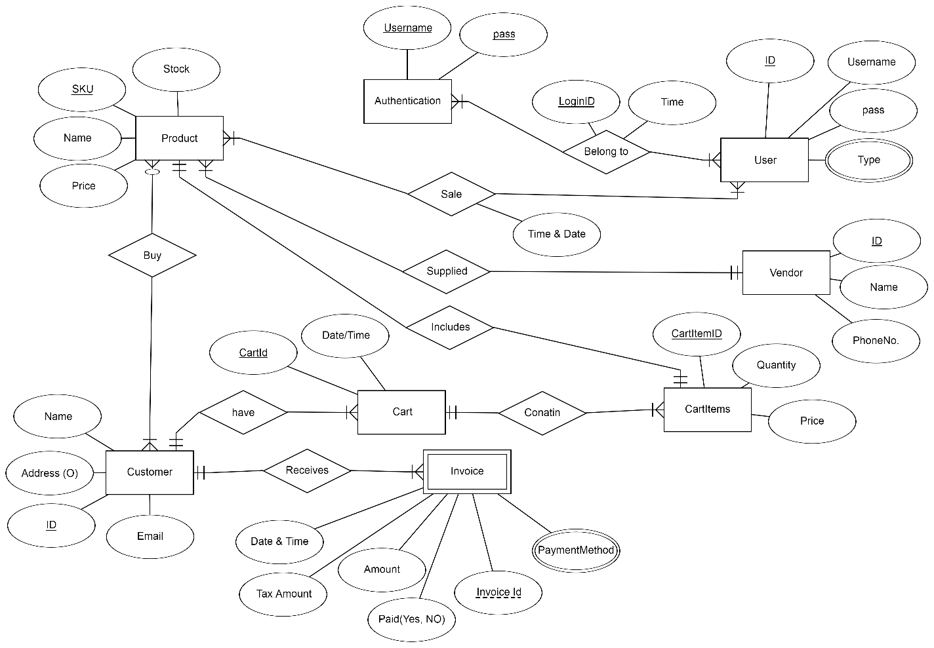

**SCHEMA OF POS:**

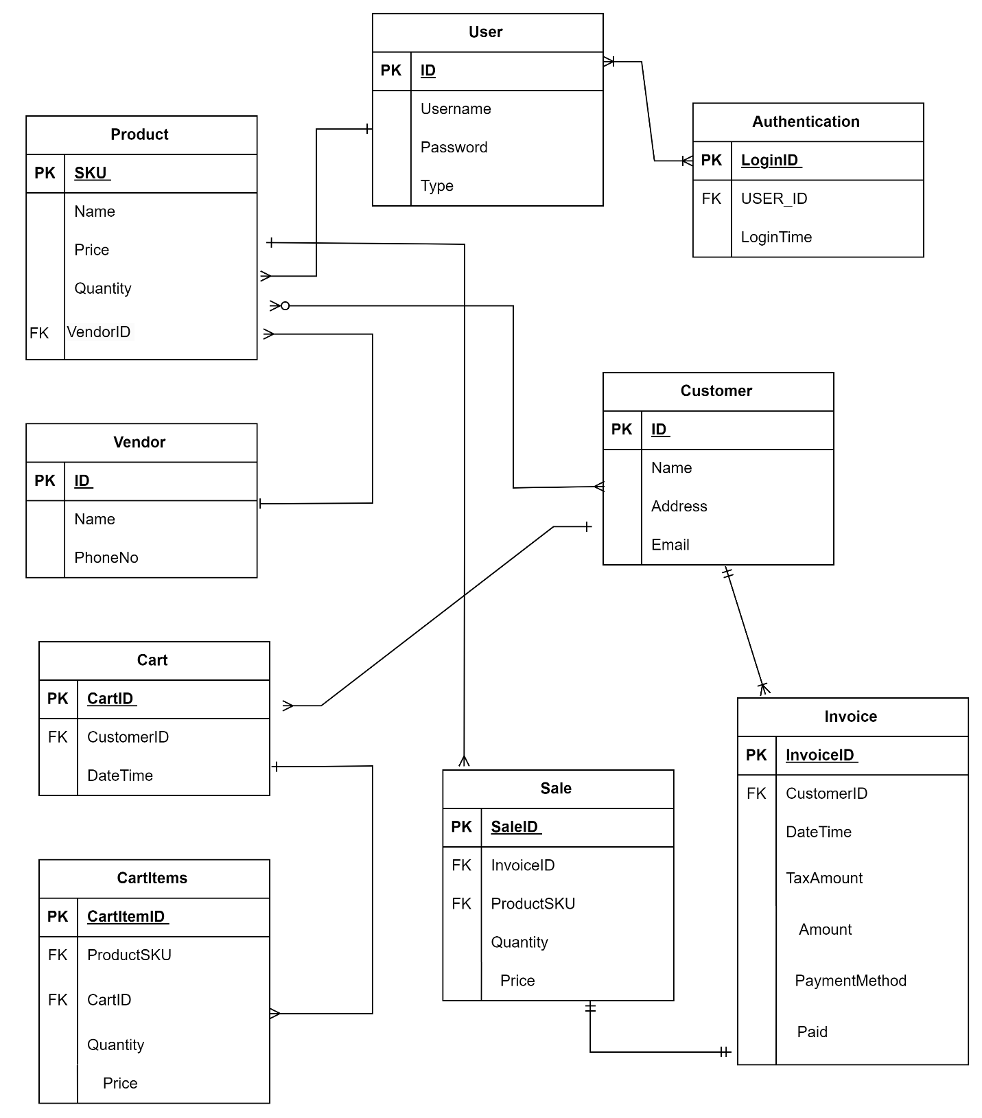

**CREATION OF TABLES**

* **Users**

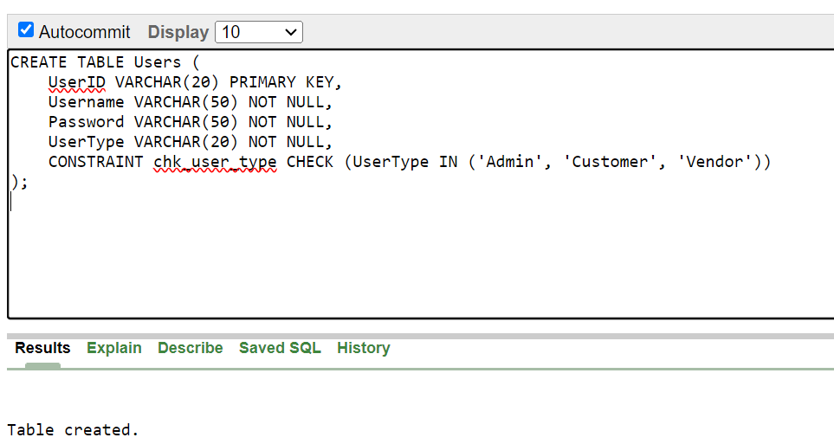

* **Authentication_Table**

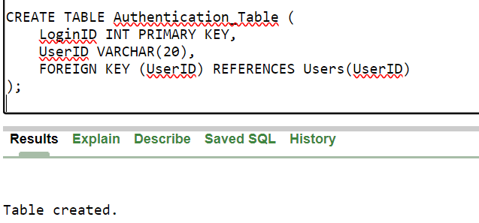

* **Vendor**

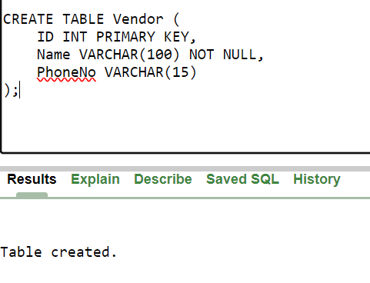

* **Product**

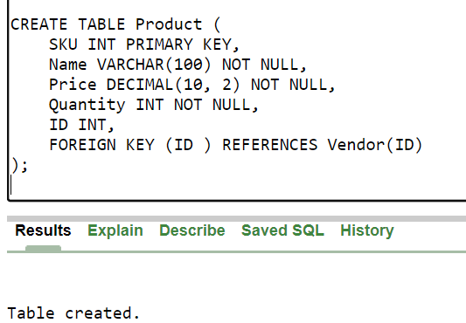

* **Customer_**

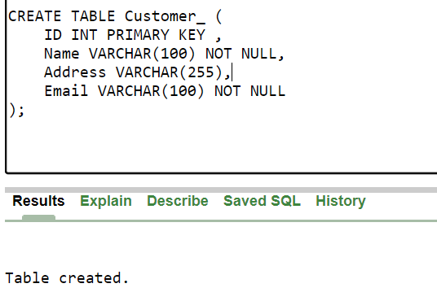

* **Cart**

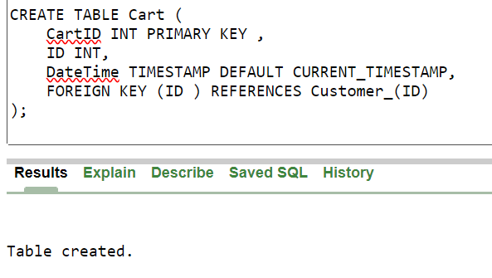

* **CartItems**

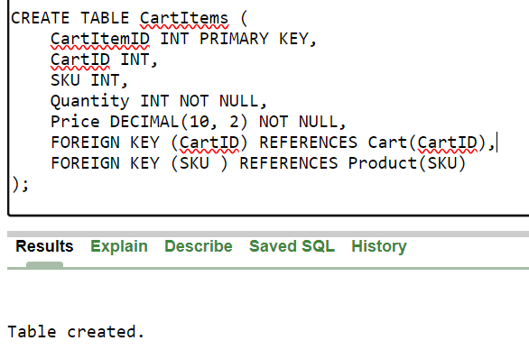

* **Invoice**

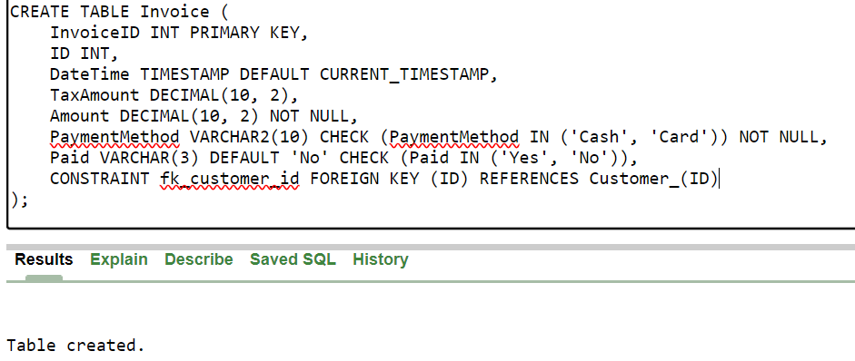

* **Sale**

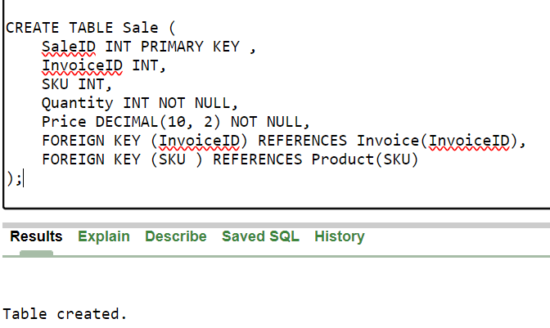

**Inserted rows in Users:**

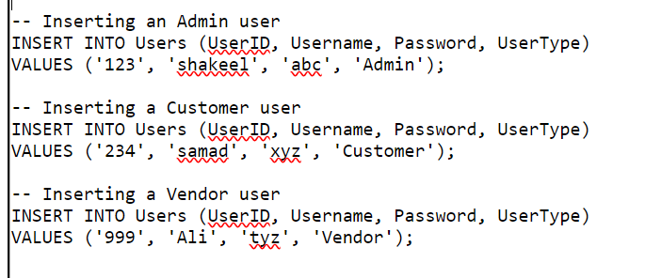

**Result**

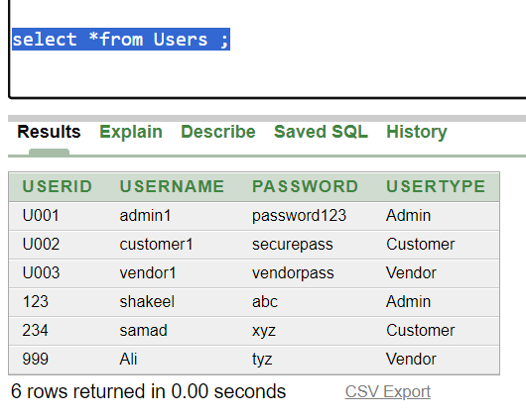

**Inserted rows in Authentication_Table:**

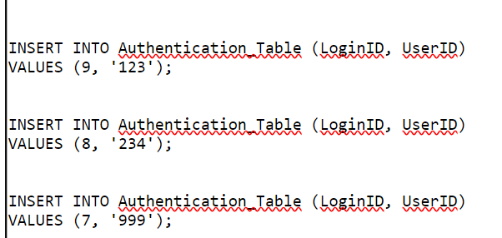

**Result**

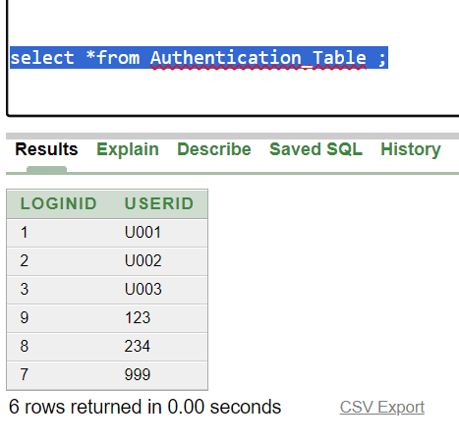

**Inserted rows in Vendor:**

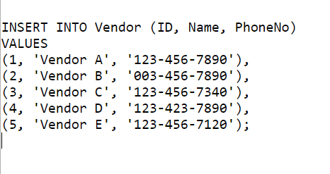

**Result:**

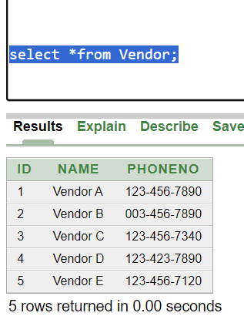

**Inserted rows in Product:**

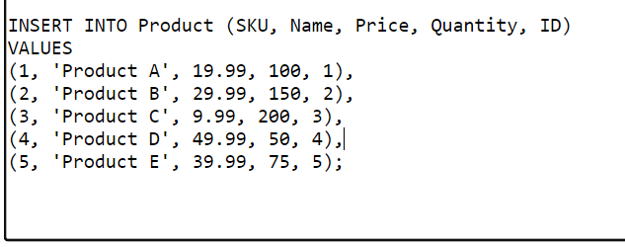

**Result:**

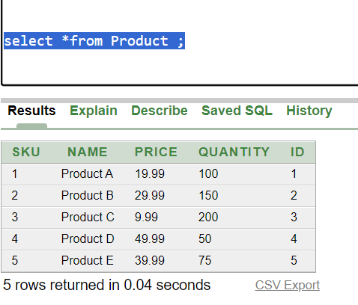

**Inserted rows in Customer_:**

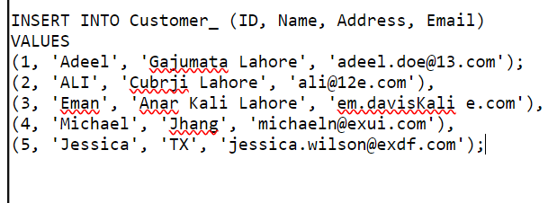

**Result:**

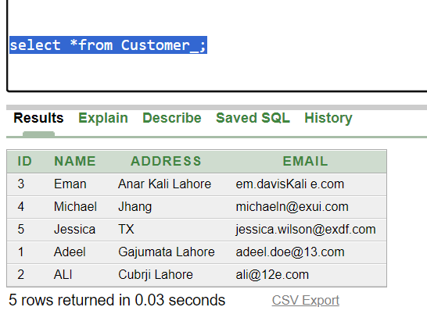

**Inserted rows in Cart**

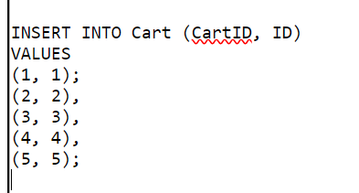

**Result**

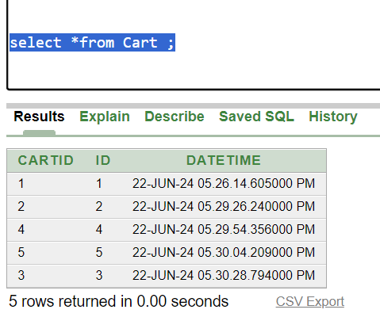

**Inserted rows in CartItems**

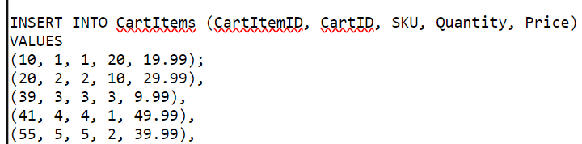

**Result**

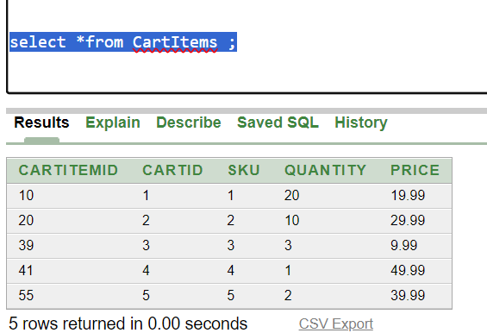

**Inserted rows in Invoice**

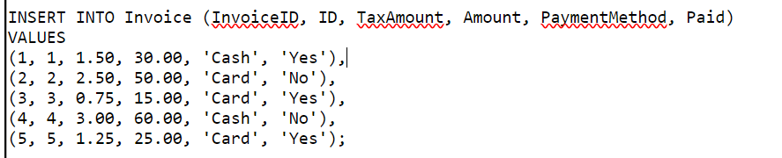

**Result**

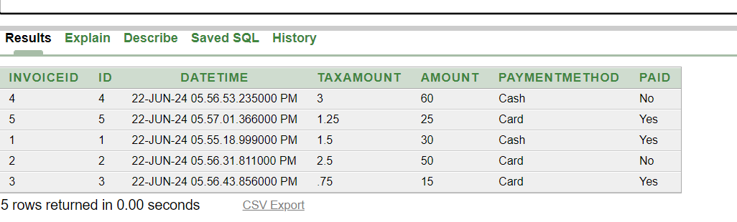

**Inserted rows in Sale**

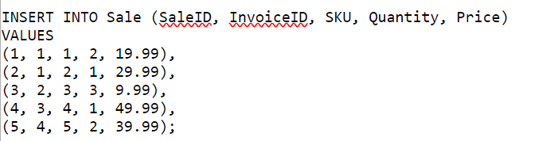

**Result**

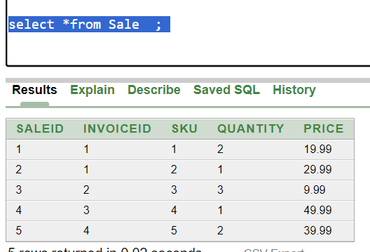

**Update sale table**

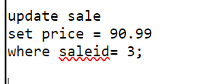

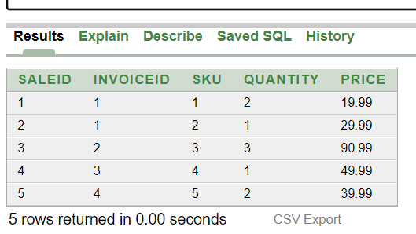

**Add Column**

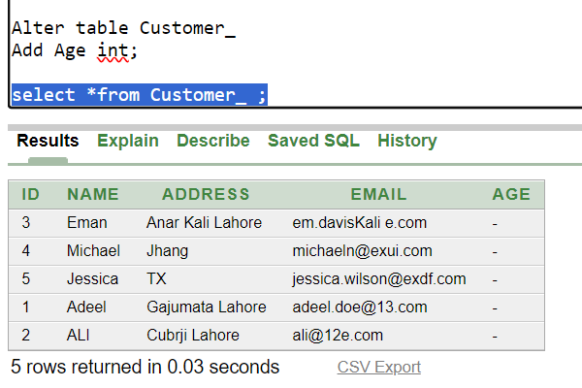

**Rename:**

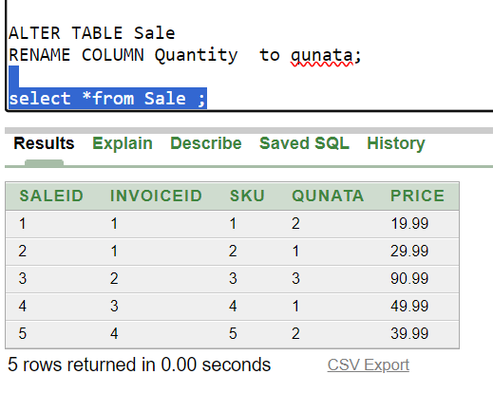

**AGGREGATE FUNCTION**

* **MIN**

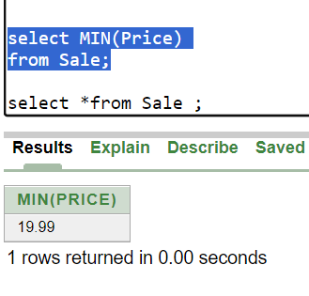

* **MAX**

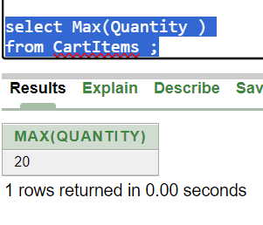

* **COUNT**

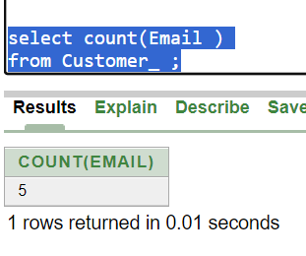

* **SUM**

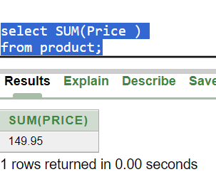

* **AVG**

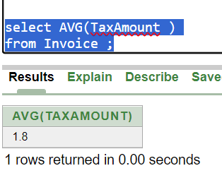

**JOINS**

* **Left Join**

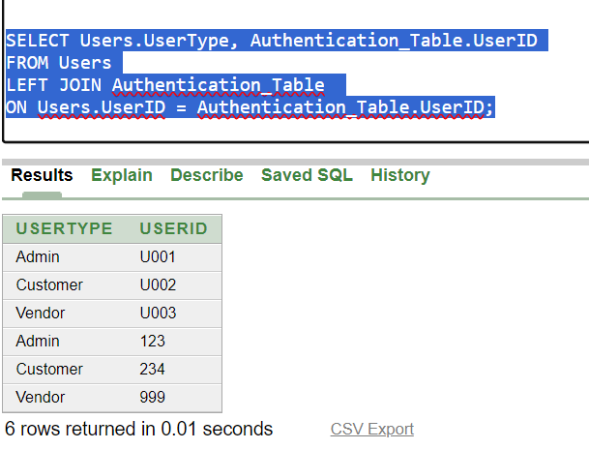

* **Right Join**

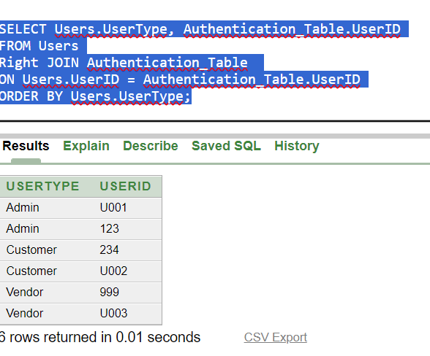

* **Inner Join**

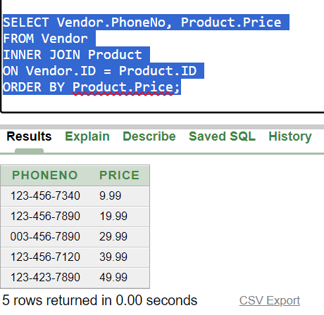

* **Full outer Join**

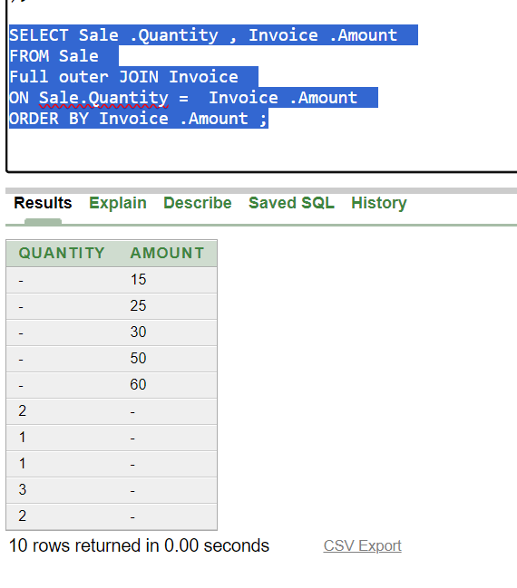

**Nested (Subqueries)**

**1.**

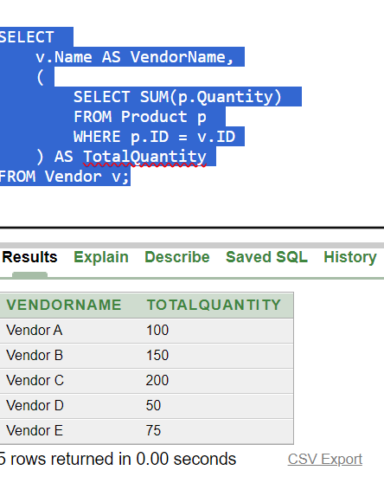

**2.**

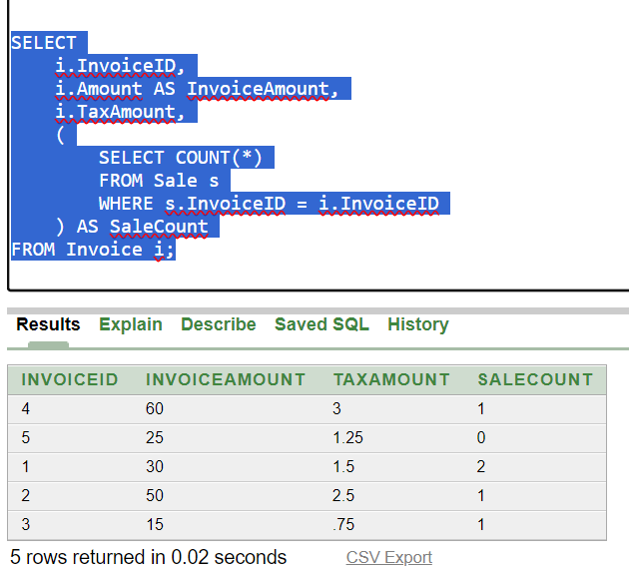

**3.**

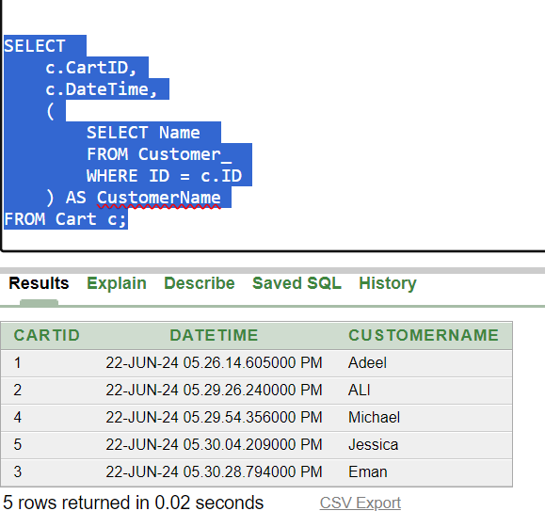

**Normalization**

Now apply normalization on Active POS system through the

* First Normal Form (1NF),
* Second Normal Form (2NF),
* Third Normal Form (3NF),
* Boyce-Codd Normal Form (BCNF).

**Product table**

|  |  |  |  |
| --- | --- | --- | --- |
| **ProductID** | **Name** | **VendorID** | **Vendor_Name** |
| 1 | ProductA | 4 | Vendor_A |
| 2 | ProductB | 5 | Vendor_B |

* **First Normal Form (1NF)**

|  |  |  |  |
| --- | --- | --- | --- |
| **ProductID** | **Name** | **VendorID** | **SupplierName** |
| 1 | ProductA | 2 | Vendor_E |
| 2 | ProductB | 1 | Vendor_C |

The given table already satisfies 1NF as all values are atomic and the records are unique.

* **Second Normal Form (2NF)**

The primary key of the table is ProductID. Vendor_Name is dependent on VendorID, not directly on ProductID. This indicates a partial dependency.

To resolve this, we separate the table into two tables:

Product Table (with primary key ProductID)

Vendor Table (with primary key VendorID).

Product Table

|  |  |  |
| --- | --- | --- |
| **ProductID** | **Name** | **VendorID** |
| 1 | ProductA | 1 |
| 2 | ProductB | 3 |

Vendor Table

|  |  |
| --- | --- |
| **VendorID** | **Vendor_Name** |
| 1 | Vendor_C |
| 3 | Vendor_B |

* **Third Normal Form (3NF)**

3NF requires the table to be in 2NF and all the attributes to be functionally dependent only on the primary key (no transitive dependency).

Product Table: In 2NF and no transitive dependencies are present.

Vendor Table: In 2NF and no transitive dependencies are present.

* **Boyce-Codd Normal Form (BCNF)**

Product Table:

In 3NF and the only functional dependency is ProductID -> {Name, VendorID}, where ProductID is a super key.

Vendor Table:

In 3NF and the only functional dependency is VendorID -> Vendor_Name, where VendorID is a super key.

* **Final Normalized Tables**

Product Table

|  |  |  |
| --- | --- | --- |
| **ProductID** | **Name** | **VendorID** |
| 1 | ProductA | 4 |
| 2 | ProductB | 5 |

Vendor Table

|  |  |
| --- | --- |
| **SupplierID** | **Vendor_Name** |
| 100 | Vendor_A |
| 101 | Vendor_D |